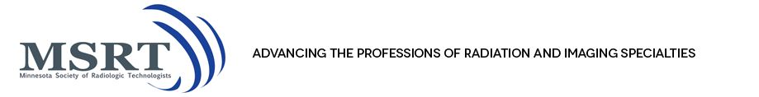

Minnesota Society of Radiologic Technologists
77th Annual Meeting and Fall Educational Conference
September 11 and 12, 2015 Best Western Kelly Inn St. Cloud, MN
Hotel: 320-253-0606
Please read carefully and COMPLETE all requested information!

NAME: _____________________________________________ MSRT COMMITTEE OFFICER:____________
(Print your name exactly as you would like it to appear Please indicate position currently held)
on your nametag, including all credentials!)
ADDRESS: ______________________________________________________________
CITY: ________________________________ STATE: _______ ZIP CODE: __________
E-mail Address: _____________________________________________________________________
(E-mail address will only be used to notify you of MSRT business/happenings)

Circle the correct MEMBERSHIP | MSRT Member | MSRT Life  Member | MSRT Honorary Member | MSRT Student  Member
SECTION A: CONFERENCE REGISTRATION: YOUR REGISTRATION INCLUDES ALL FOOD OFFERINGS. HONORS BANQUET TICKET IS INCLUDED IN BOTH DAY AND FRIDAY ONLY REGISTRATION.
You may ONLY choose ONE category!
ALL Affiliate Society Members may register at the MSRT Member price. Proof of current non-
Minnesota affiliate membership MUST be included with registration.

Circle the correct attendance choice | MSRT MEMBER | NON-MSRT  MEMBER | ALL  STUDENTS
Both Days | $200.00 | $250.00 | $130.00
Friday Only | $100.00 | $130.00 | $65.00
Saturday Only | $100.00 | $130.00 | $65.00
HOTEL ACCOMODATIONS: A block of rooms have been reserved at the Kelly Inn for the conference until 8/28/2015. The rate is $86.00/night. Call the Kelly Inn directly for reservations. (320)253-0606

IMPORTANT NOTE: For Both Day and Friday Only registrants, will you be attending the
Honors (included in registration) Banquet? ____ Yes No ____

SECTION B: ADDITIONAL GUEST MEAL PURCHASE
 | QUANTITY | Price/meal | TOTAL AMOUNT
Honors Banquet |  | $32.00
Friday Vendor Appreciation Luncheon |  | $17.00
Saturday President’s Luncheon |  | $17.00

Total REGISTRATION and Additional MEAL fees: ________________________

Please indicate any special dietary needs: ____________________________________________________

Make checks payable to: MSRT EDUCATIONAL CONFERENCE 2014
Return Registration Form and your Educational Session Selection Forms to:

JoAnn Swiggum 508 Spruce Grove Ln NW Bemidji, MN 56601

Additional forms available at: www.mnsrt.com On-line registration is also available at www.mnsrt.com

FOR REGISTRATIONS POSTMARKED AFTER SEPTEMBER 1, 2015, ADD AN ADDITIONAL $20.00 REGARDLESS OF REGISTRATION TYPE! NO SAME DAY REGISTRATIONS WILL BE ALLOWED!
**REGISTRATIONS RECEIVED AFTER SEPTEMBER 8, 2015, MAY BE RETURNED!**

